Individual Contribution and Reflective Report
Student Name: Robert RIgler | SID: 4939377
Assignment: Part 1
Activity Title:

Sprint 1 : Use Case Diagram and Use Case Processes

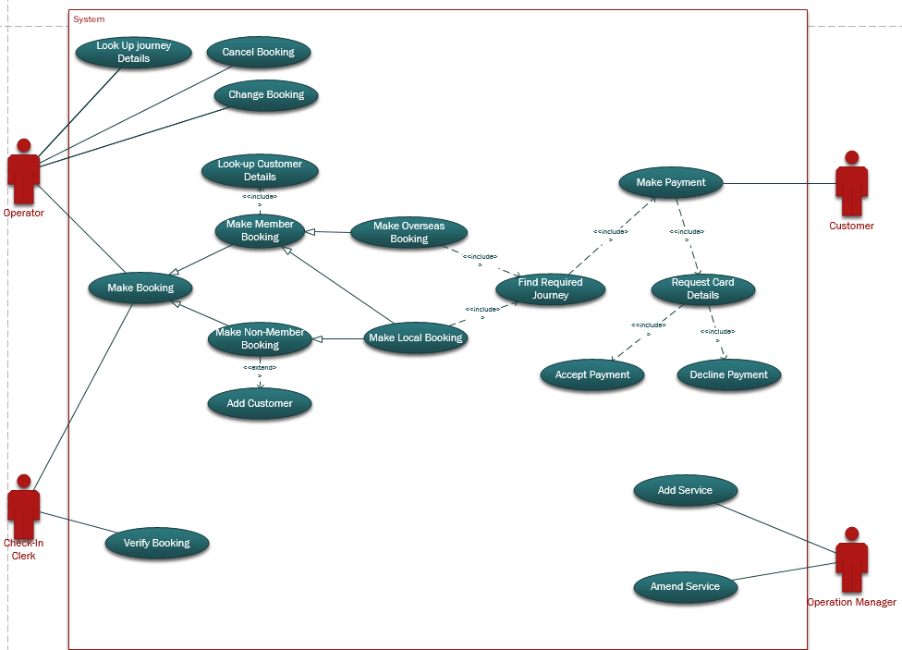

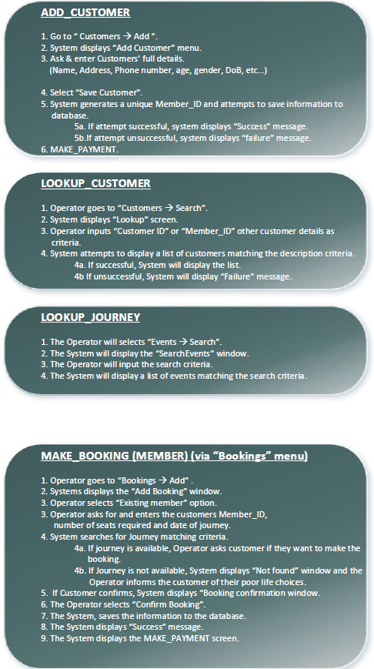

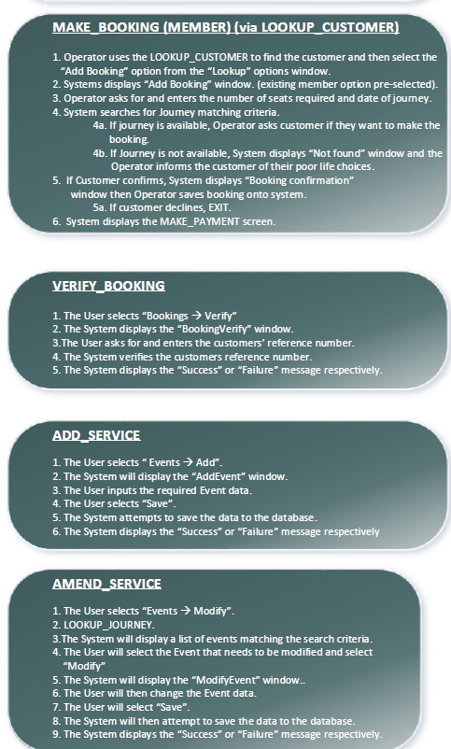
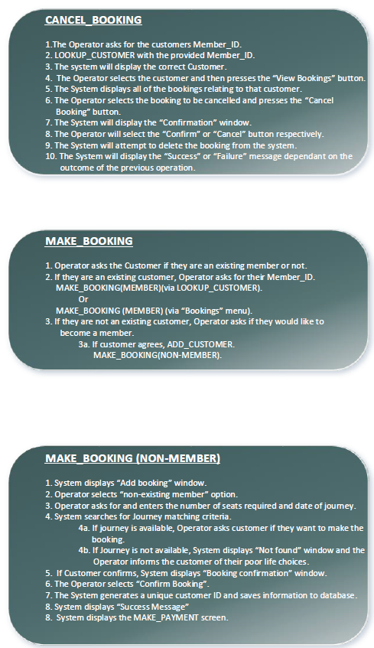

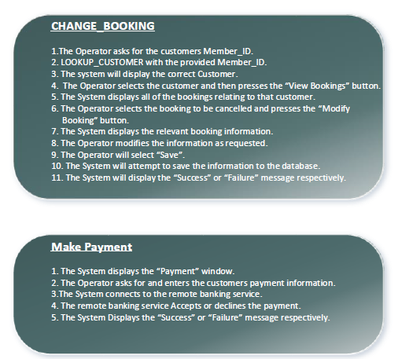

Sprint 2: Analysis Class Diagram

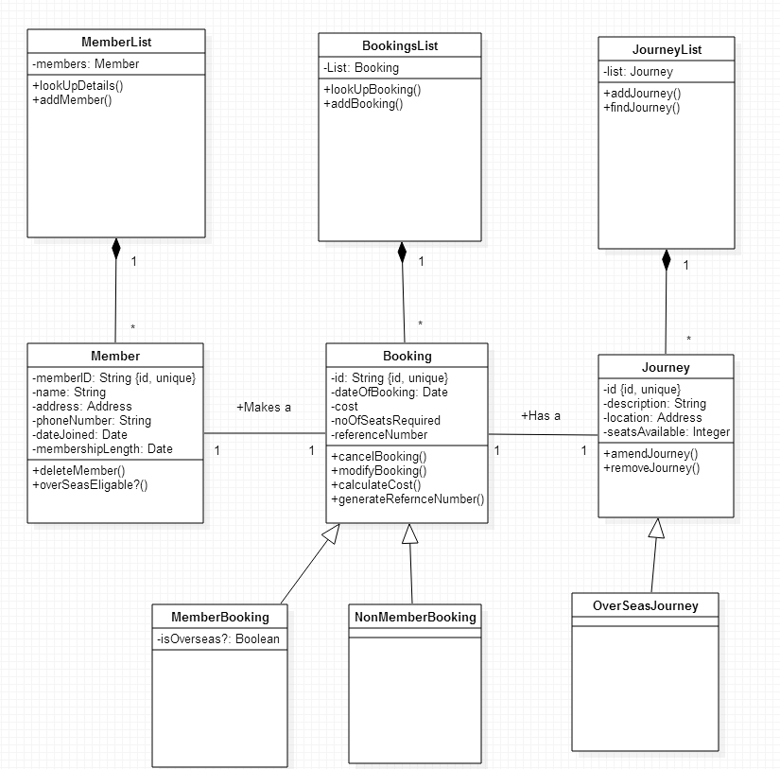

Overall I am pleased with my individual contribution and the group progress in these two tasks. The importance of well-planned use cases and classes in the analysis stage of the development process is key to overall success of the project. Particularly in the area of class diagrams. Having less specific but still viable representations of the system at this early stage, greatly improves overall group understanding of the project as a whole. The use cases contribute this, because we can now see very clearly how the external entities and the nature of their interaction with different parts of the system.

Individual Contribution and Reflective Report
Student Name: Robert Rigler | SID: 4939377
Assignment: Part 2
Activity Title:

Sprint 4: Class Diagram

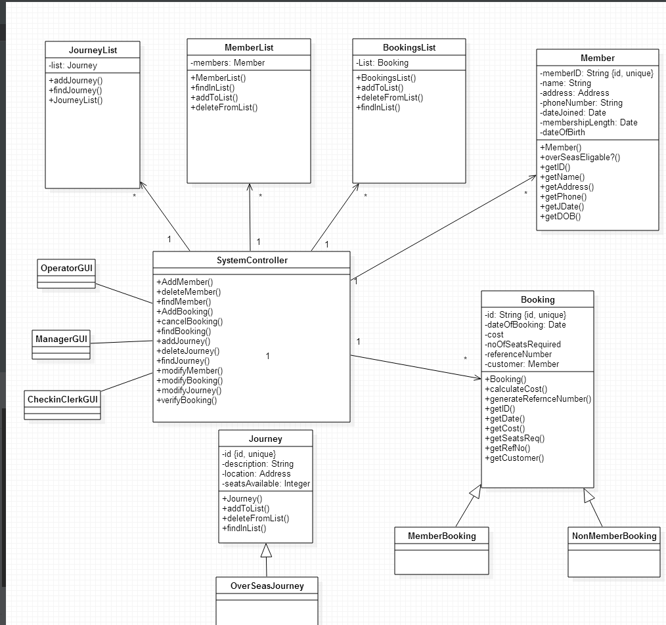

Sprint 6: Pseudocode and code generation

START
OBTAIN Journey details
OBTAIN Journey Date
OBTAIN Number_of_Seats_required

FOR EACH Journey in JOURNEY_LIST
IF Journey_Details = Journey
Journey_found = true
ELSE NEXT
END IF
END FOR

IF Journey_Found = false
OBTAIN Journey Details AGAIN

ELSE (Journey_Found = true)
MAKE_BOOKING()
END IF
END

MAKE_BOOKING()

IF customer is a member
Finalize Booking
GO_TO_PAYMENT

ELSE (customer is not member)
IF customer wants to be a member
Enter new member details
ELSE
GO_TO_PAYMENT
END IF
END IF

END

PAYMENT()

GET payment_details
VERIFY PAYMENT

IF payment not verified
STOP
END IF

ISSUE Reference_number

For the generated Please see the folder Marked ‘Generated code ’ in the submission folder.

Sprint 8: Test Plans

Test ID | Description | Test Data | Expected  Result | Result | Status
1 | Test the method that identifies a customer
1.1
1.2
1.3
1.4

TestPlan for Customer Identificatin

